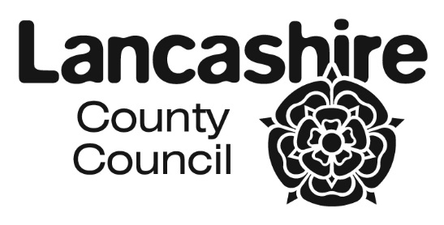
CO-ORDINATED ADMISSION SCHEME FOR
LANCASHIRE SCHOOLS AND ACADEMIES 2022/2023
SEPTEMBER 2022 INTAKES

SECONDARY |  | PRIMARY
DATE | ACTION | DATE | ACTION
1 September 2021 | Online application system goes live and requests for paper forms / booklets accepted and considered | 1 September 2021 | Online application system goes live and requests for paper forms / booklets accepted and considered
31 October 2021 | Closing date for applications  (statutory) | 15 January 2022 | Closing date for applications  (statutory)
8 November 2021 | Secondary schools / academies to forward any paper applications to Area Pupil Access Teams | 21 January 2022 | Primary schools / academies to forward any paper applications to Area Pupil Access Teams
22 November 2021 | Preferences information exchange with other Local Authorities | 28 January 2022 | Preferences information exchange with other Local Authorities
6 December 2021 | Information to be exchanged with Own Admission Authority Schools | 4 February 2022 | Information to be exchanged with Own Admission Authority Schools
13 December 2021 | Admission authority to confirm intention to exceed PAN with the LA | 11 February 2022 | Admission authority to confirm intention to exceed PAN with the LA
17 December 2021 | Prioritised (ranked) lists back to the Local Authority | 28 February 2022 | No further address changes can be accepted.
15 January 2022 | No further address changes can be accepted. | 18 March 2022 | Prioritised (ranked) lists back to the Local Authority
24 January 2022 | Further exchange of lists with other admission authorities | 25 March 2022 | Further exchange of lists with other admission authorities
14 February 2022 | No changes at all can be made to offer letters after this date | 1 April 2022 | No changes at all can be made to offer letters after this date
25 February 2022 | Issue finalised offer lists to secondary schools / academies | 16 April 2022 | Issue finalised offer lists to primary schools / academies
1 March 2022 | Issue offer letters/emails.  (statutory date is 1st March or the next working day) | 18 April 2022 | Issue offer letters/emails.  (statutory date or next working day)

The closing dates and offer dates are national statutory requirements. The dates of exchanges of information may on occasion vary slightly by agreement to take into account localised issues associated with workload and / or specific situations affecting a school / academy or a group of establishments. Occasionally delays may occur as neighbouring authorities will be working to different timetables.

Where a statutory offer date is on a weekend or public holiday Lancashire's online system will go live on the next working day.

